Essay:

**Grammar and key takeaways:**

**Always use comma before** and but

**Always use comma** after However, therefore, for instance, additionally, this means, moreover, on the one hand, on the other hand, in conclusion, This means

**Never use comma** after **such as** and **because**

article a should be used before list of singular nouns

a reforestation program, a carbon tax

‘The’ should be not be used before nouns unless taking abt historical event or the place.

Always use comma before ‘and’ ‘but’ ‘which’ ‘like’  
Always use comma after However, therefore, for instance, additionally, this means, moreover, on the one hand, on the other hand, in conclusion, This means

**“a better living standards” ❌**

* ❌ a better living standards
* ✅ **higher living standards** / **better living standards**

📌 **Rule**:  
If the noun is plural, **remove “a”**.

**Rule (Very important)**

👉 **NO “the” before country names**

**Correct**

* the United States ✅ (exception)
* Australia ✅
* Germany ✅
* India ✅
* Countries

**Memory trick**

If the country name is **plural or has “states/kingdom” → use “the”**

Don’t use ‘the’ before people

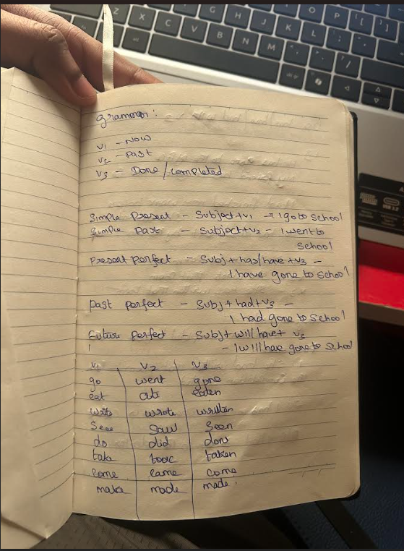

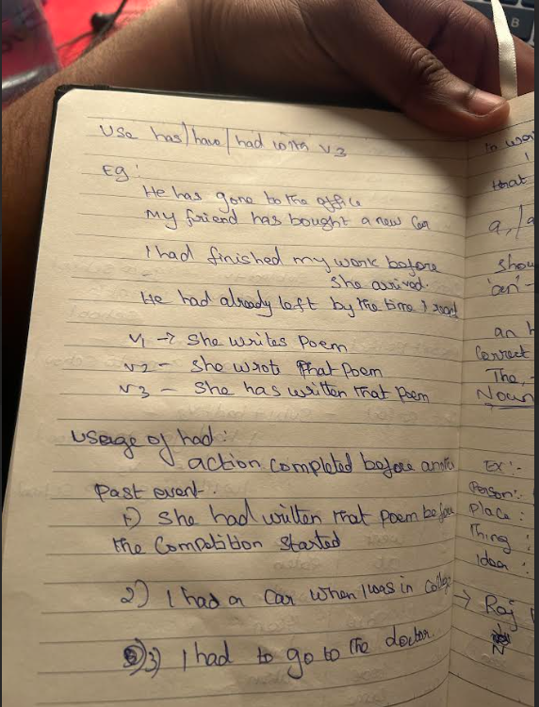

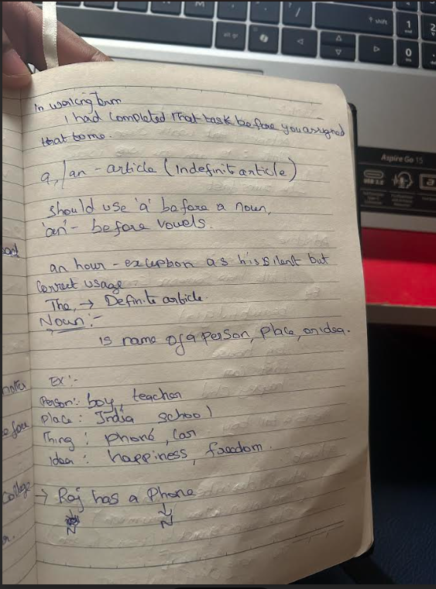

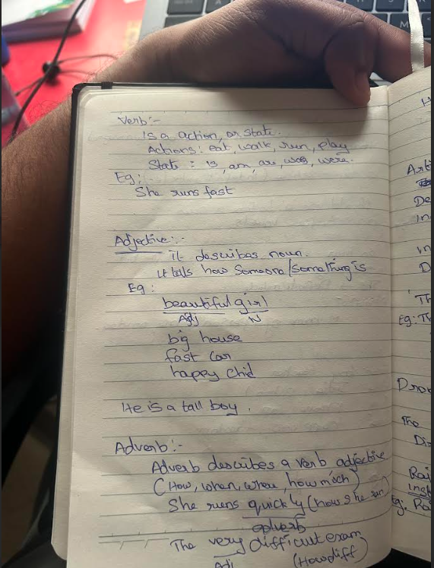

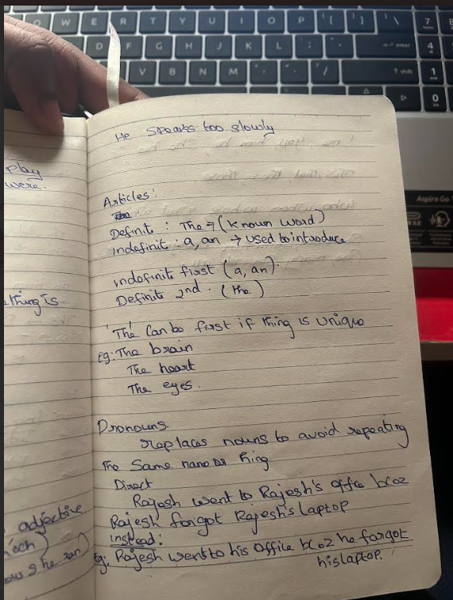

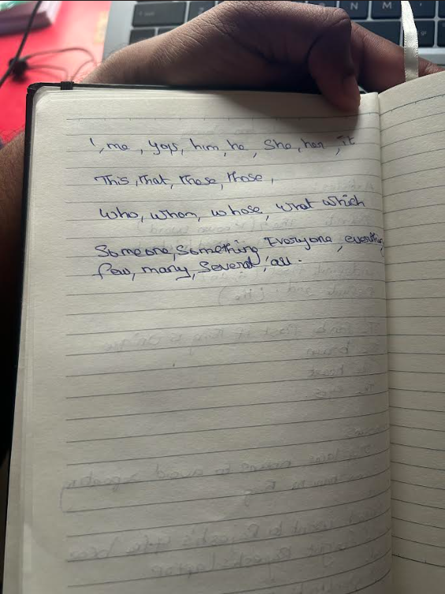

**Common introduction,**

In today’s society, while some people believe that paraphrase the statement, others argue that/disagree …. In this essay, both sides / I will explain why I agree/disagree

**Learnings from mistakes**

versus, not vs

the United States, not US or united states

PhD not PHD

agree with not agree on

disagree with

the benefits

the disadavantages

tutors not tuitors

smartphones not smart phones

convenient

Inaccessibilityf

**Words with hyphen:**

|  |  |
| --- | --- |
| well-known | a well-known singer |
| high-quality | a high-quality product |
| long-term | long-term plan |
| part-time | part-time job |
| user-friendly | user-friendly app |
| time-consuming | time-consuming task |
| full-time | full-time employee |

Day-to-day

|  |  |
| --- | --- |
| self | self-aware, self-control |
| ex | ex-president, ex-boyfriend |
| all | all-inclusive |
| co | co-operate / co-author |
| anti | anti-virus, anti-aging |
| pre | pre-school, pre-paid |
| post | post-graduate |

**Essay:**

Use either British or American

Essay must be between 200 to 300 words

Use compound or complex sentences.

**Different types of essays:**

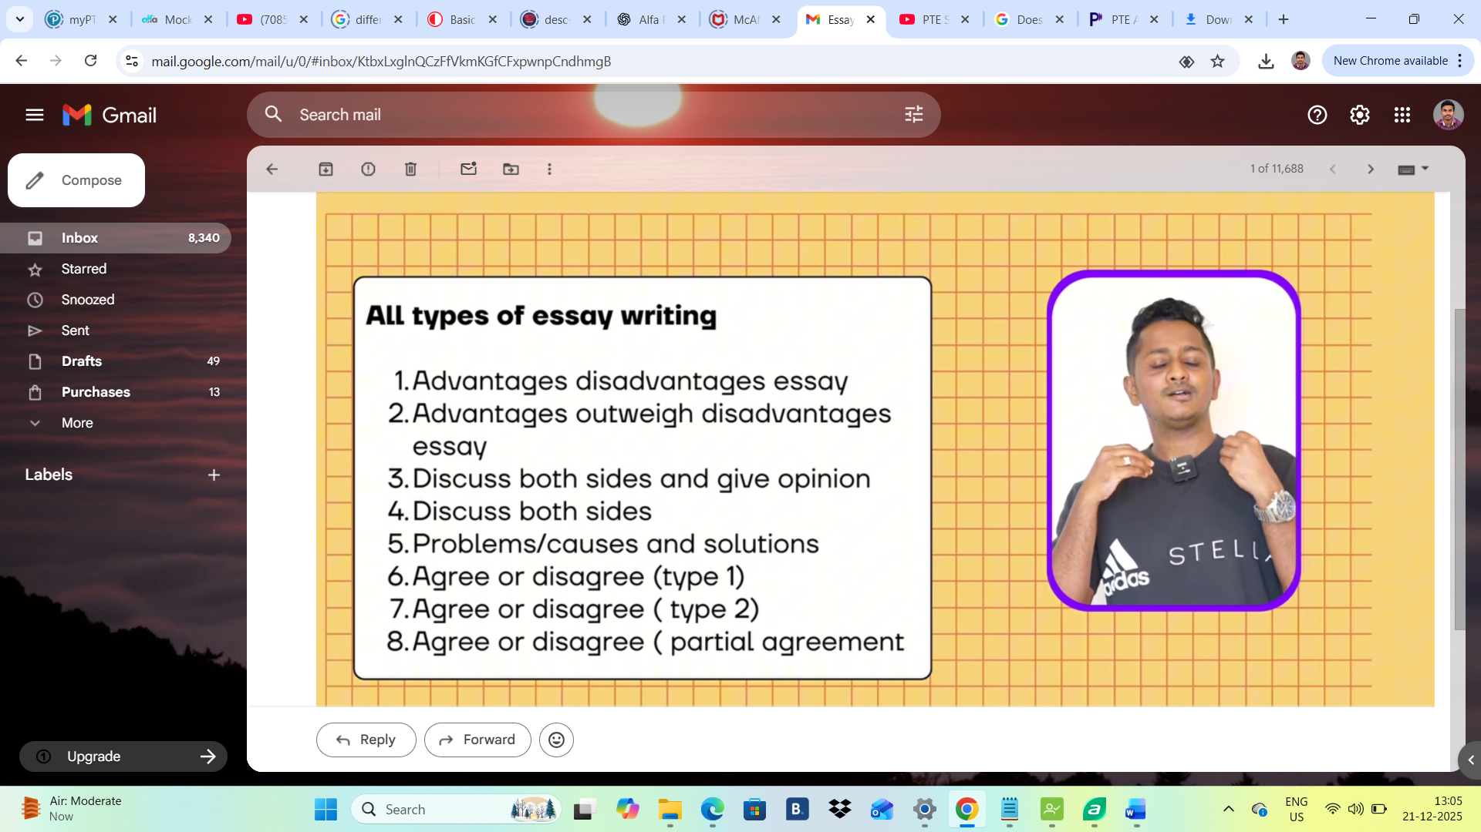

Templates:

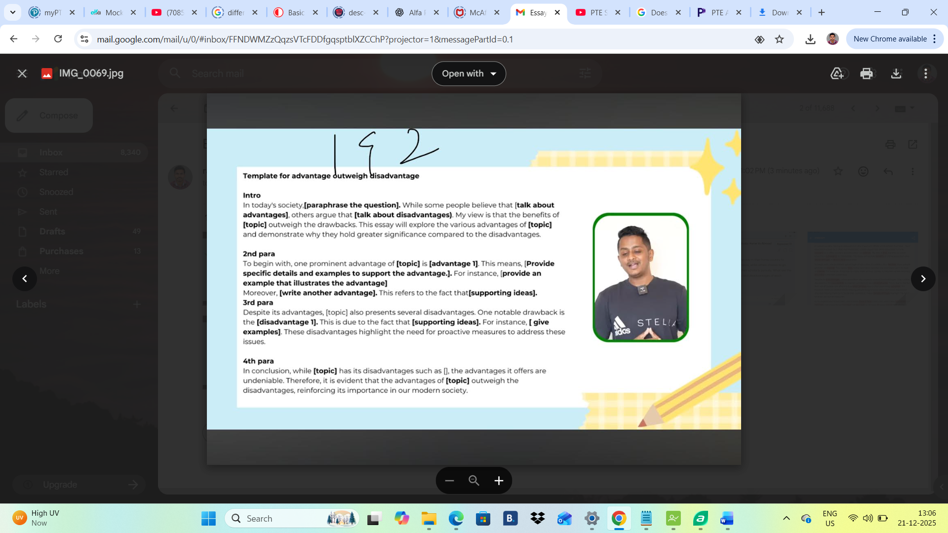

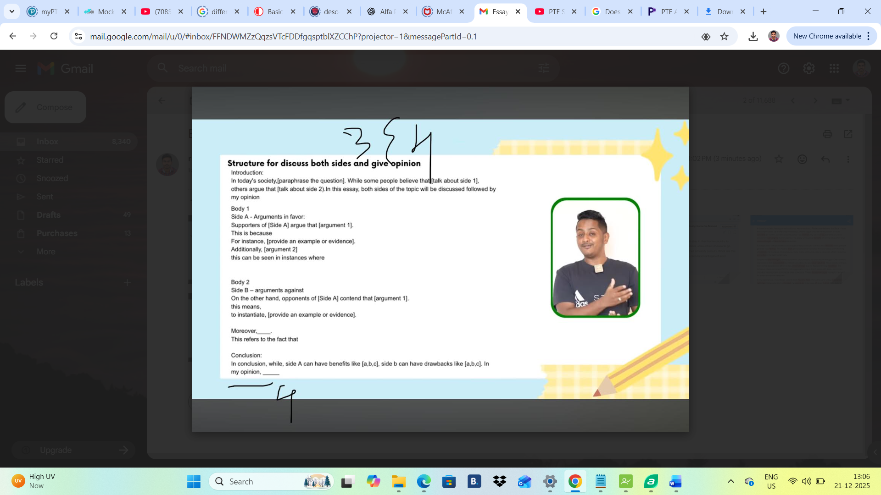

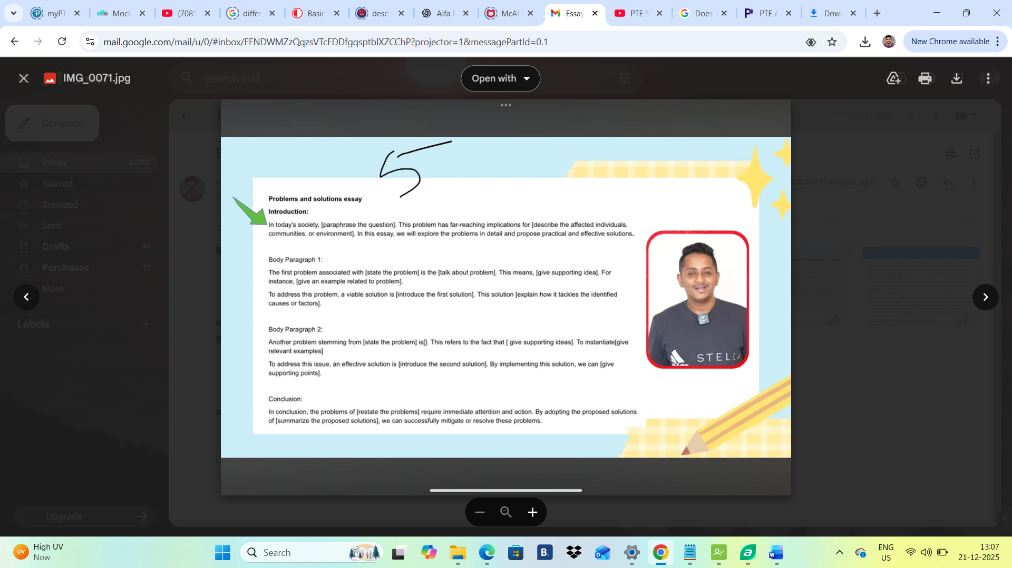

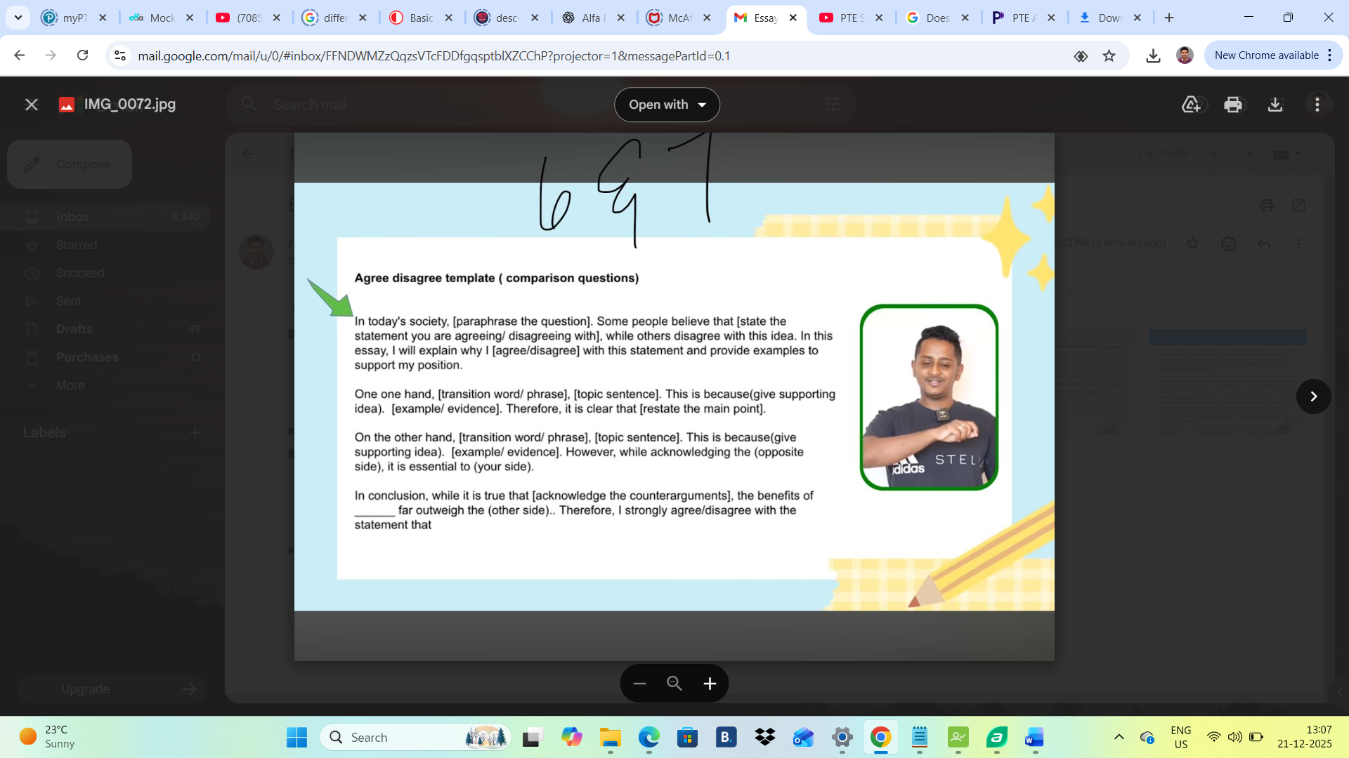

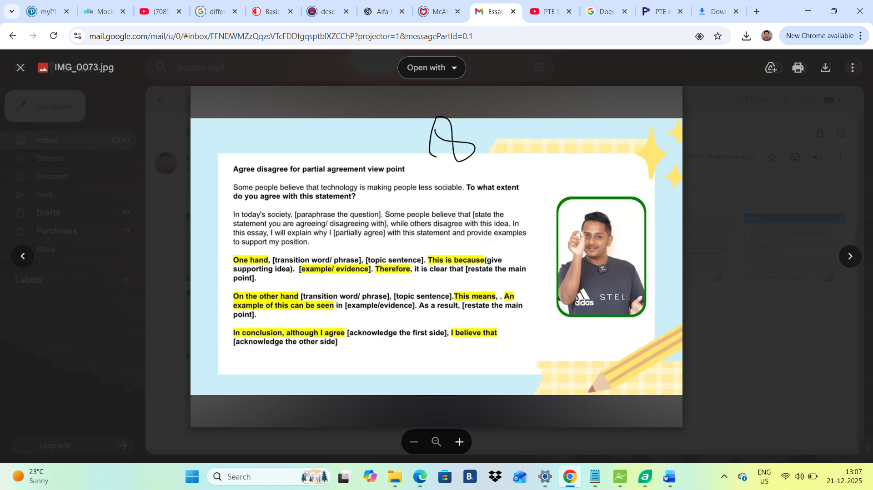

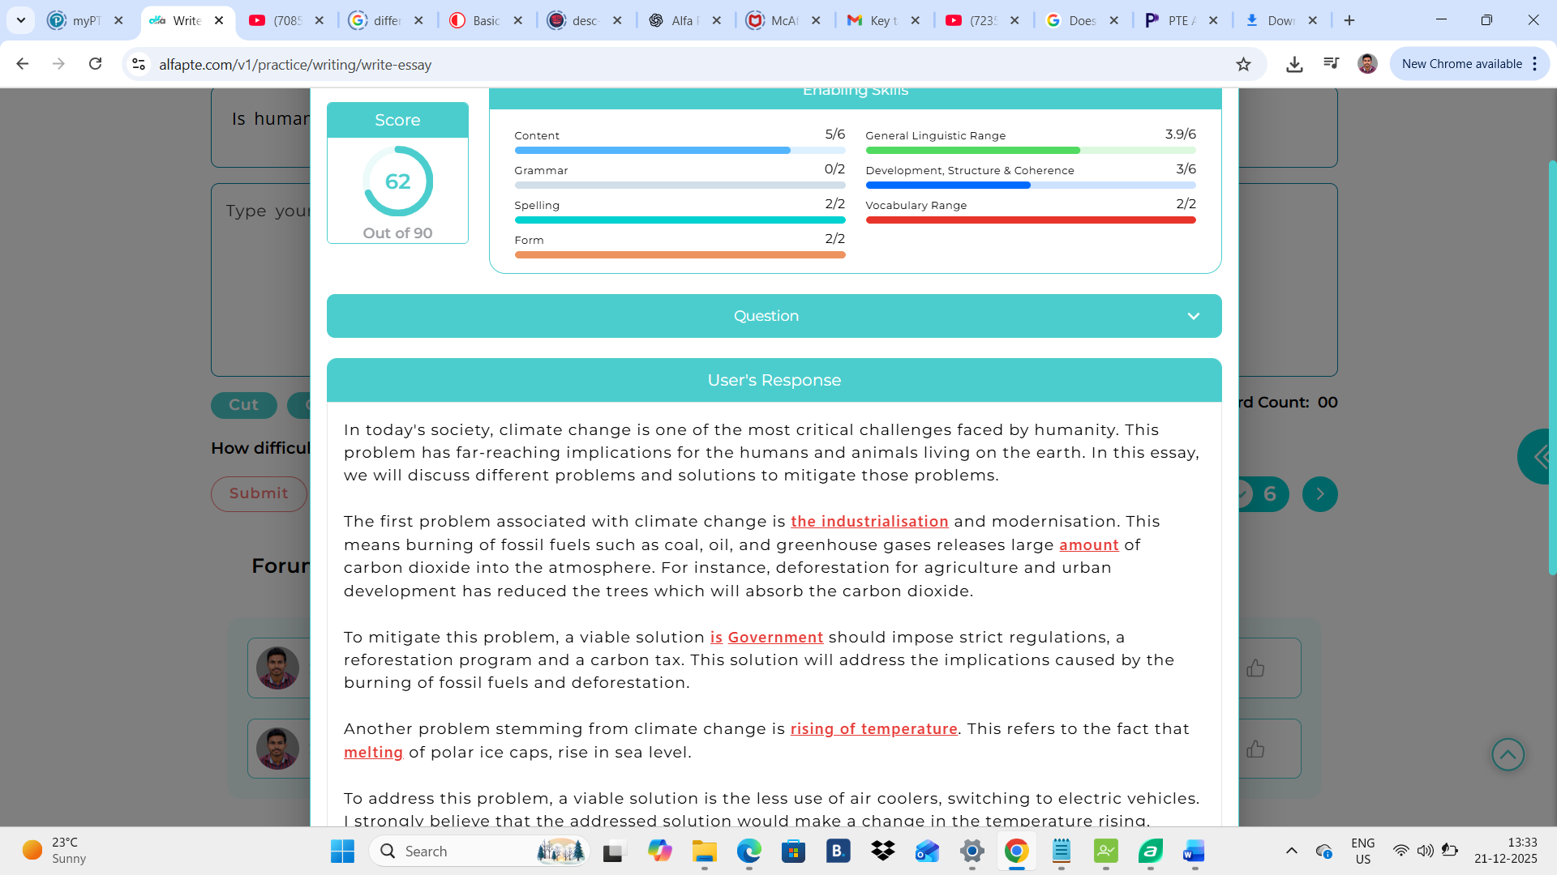

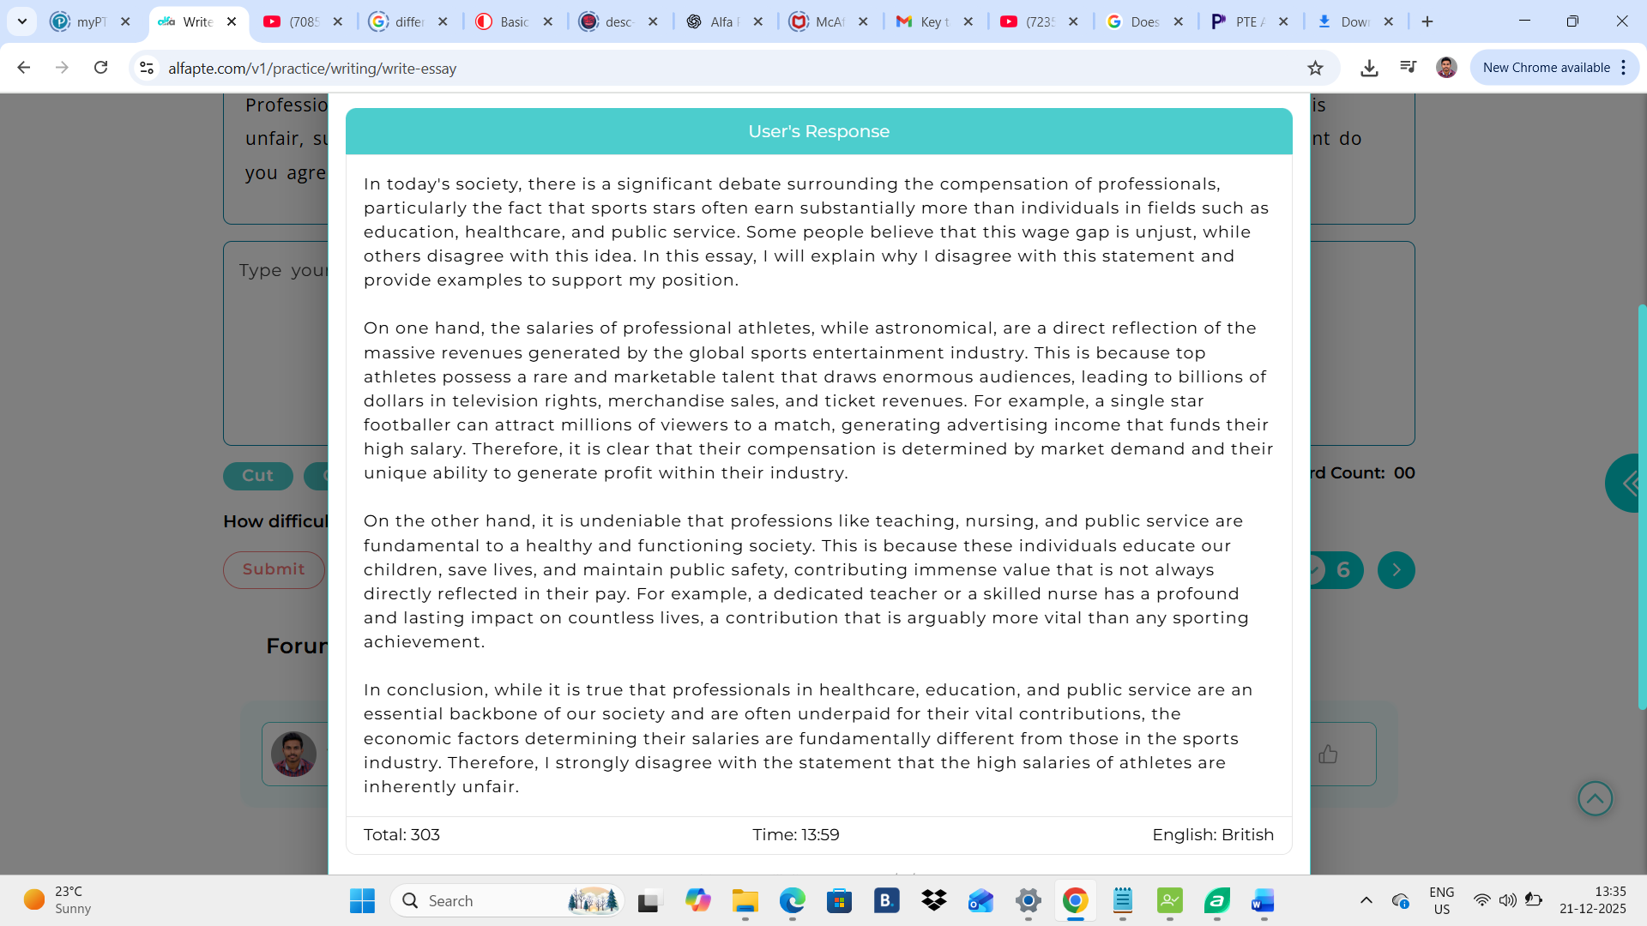

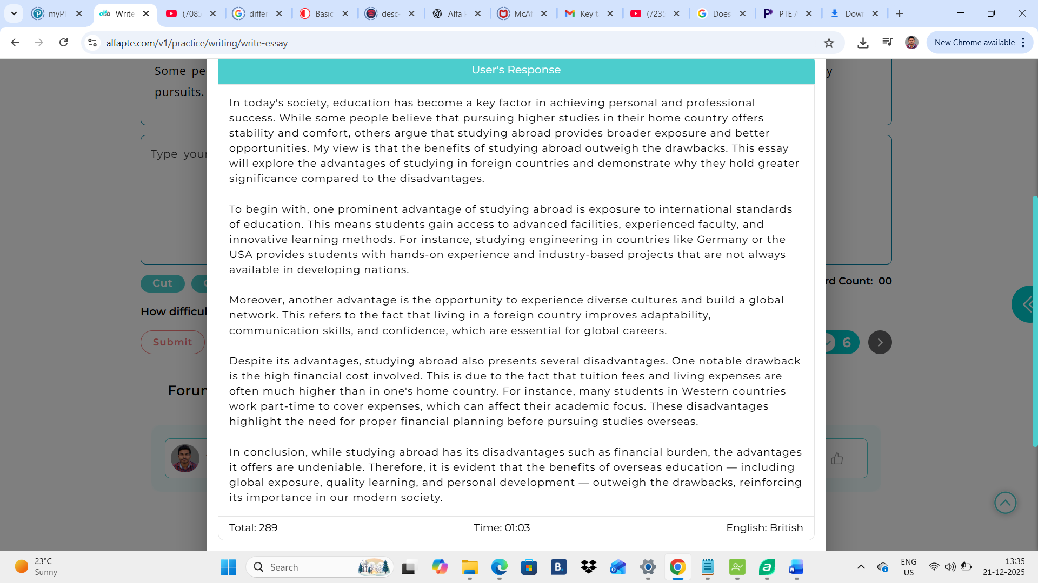

**Summarise written text:**

**In 1 sentence only, > 5 words and <75 words only**

